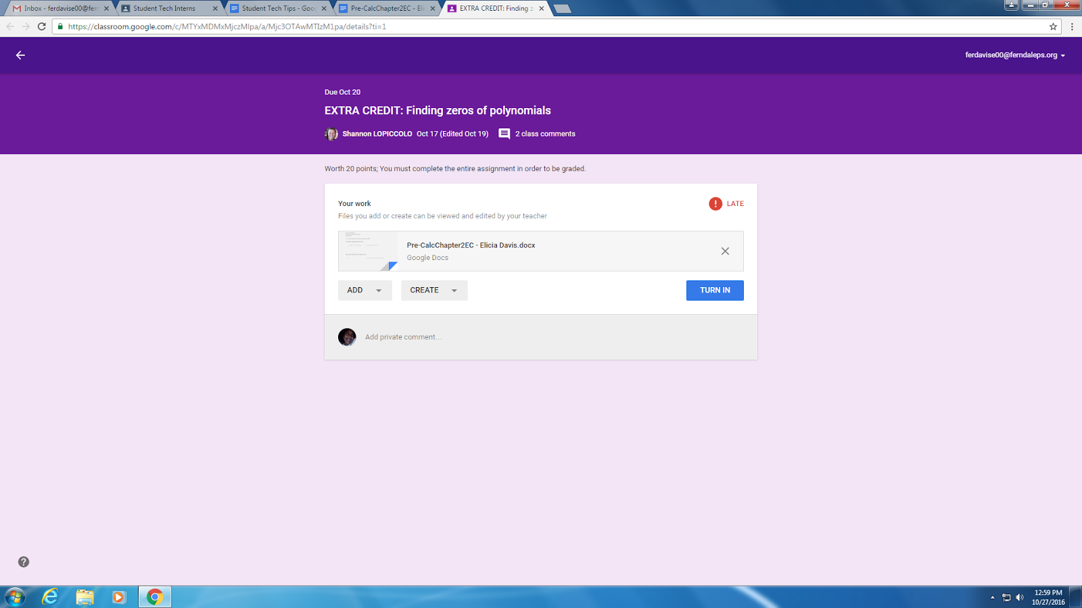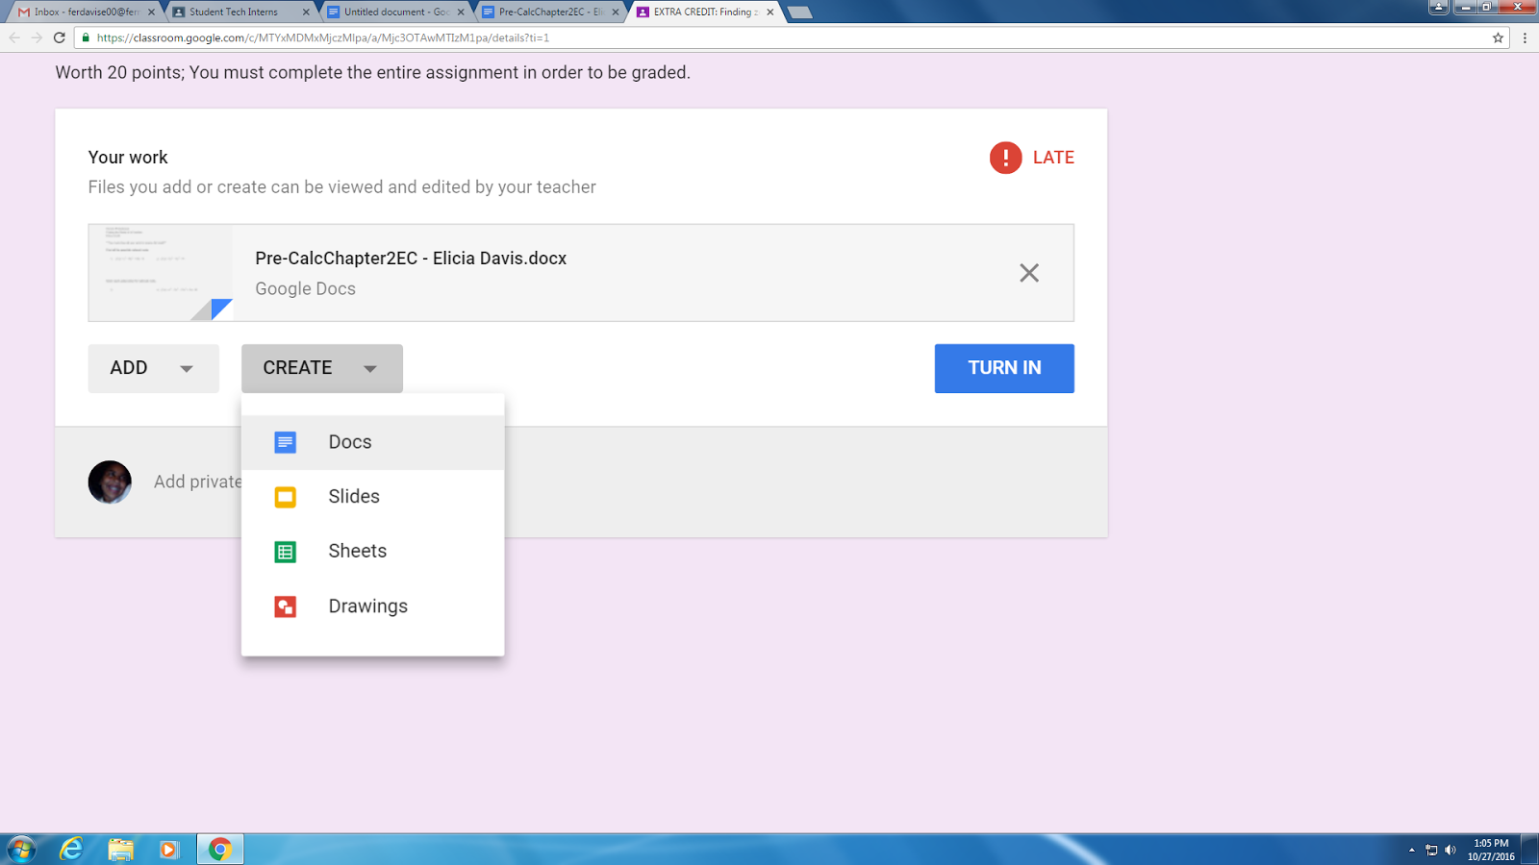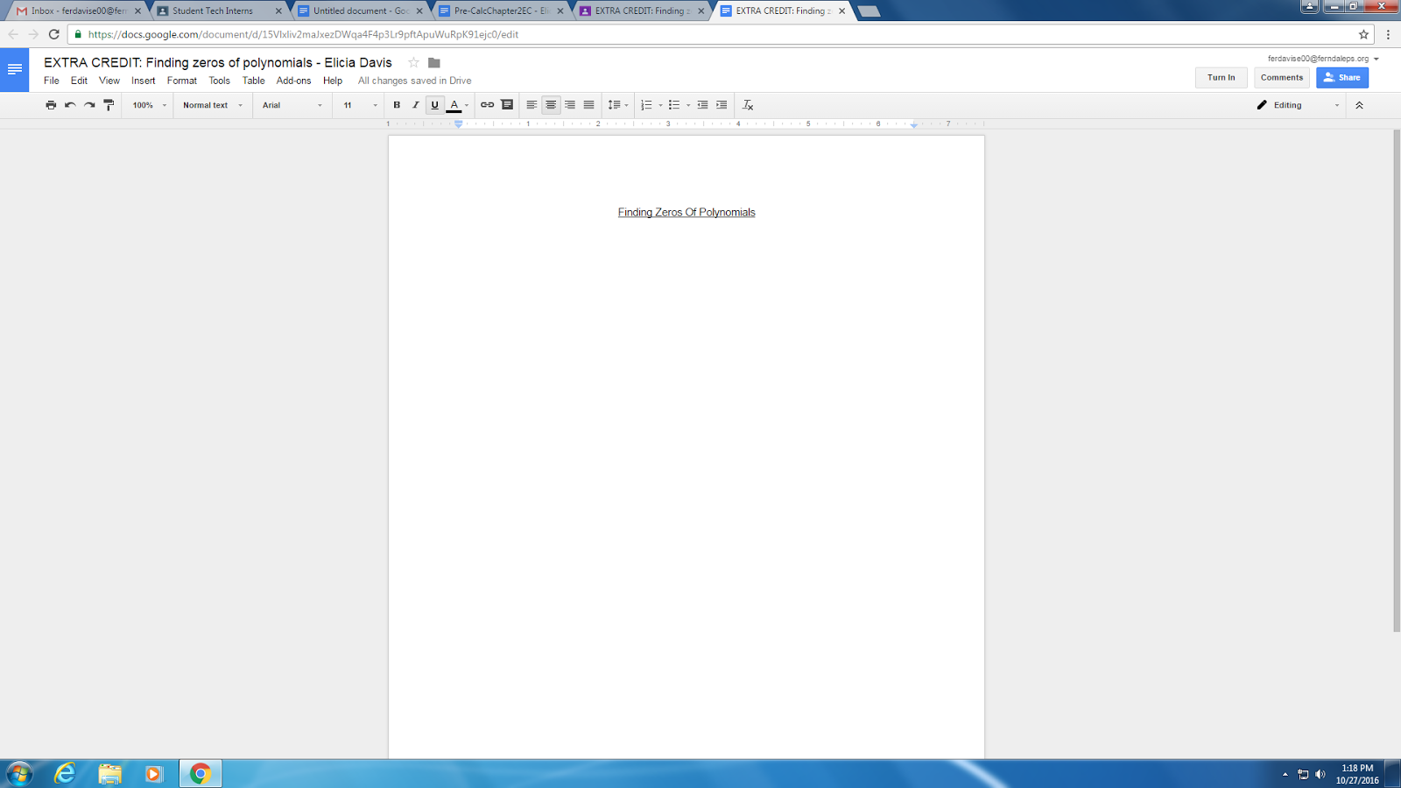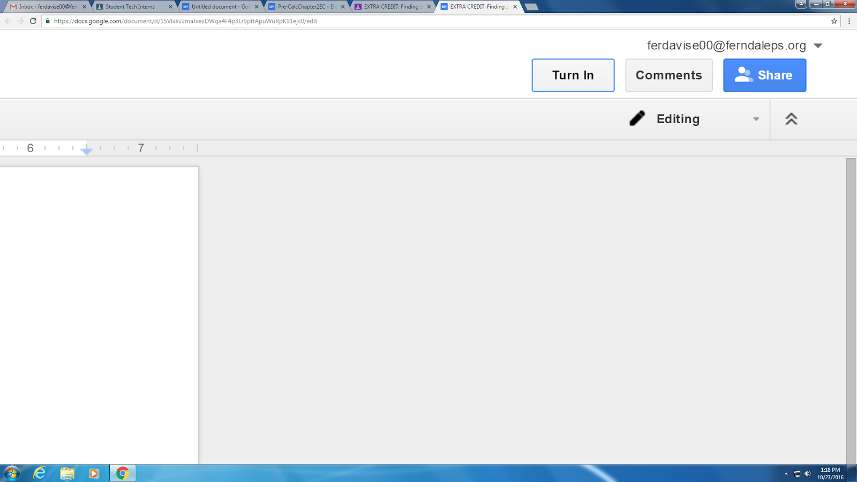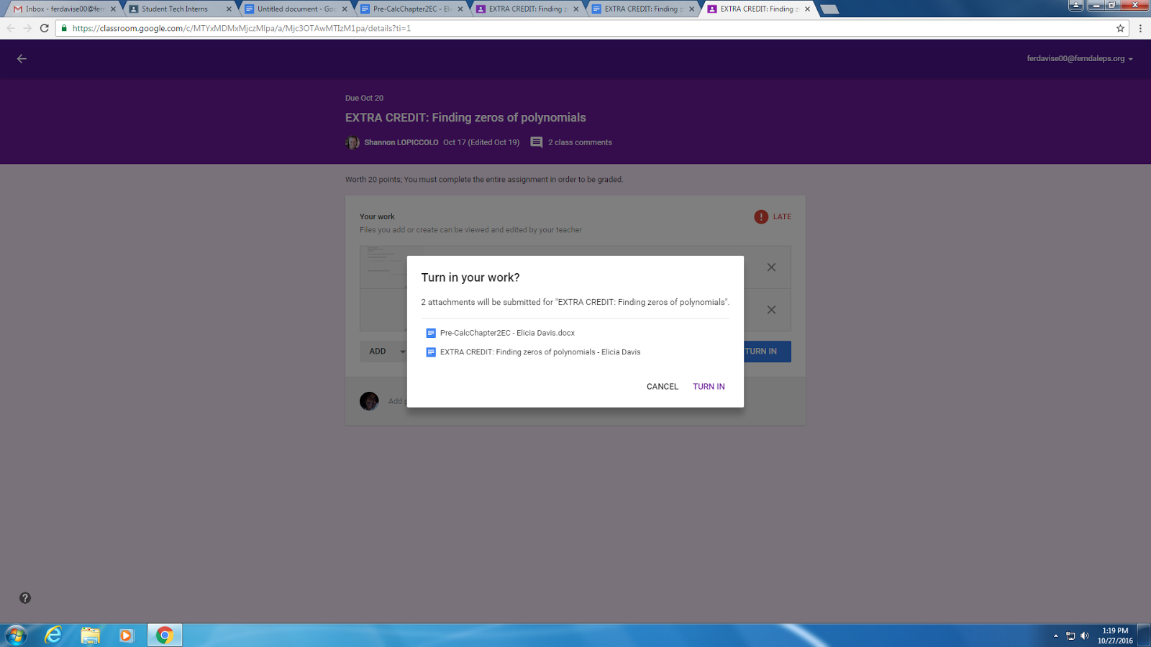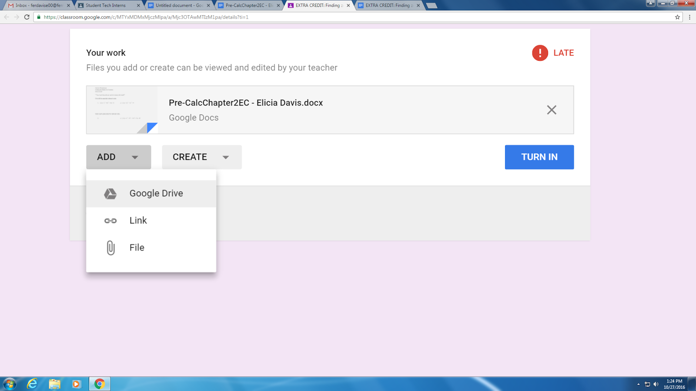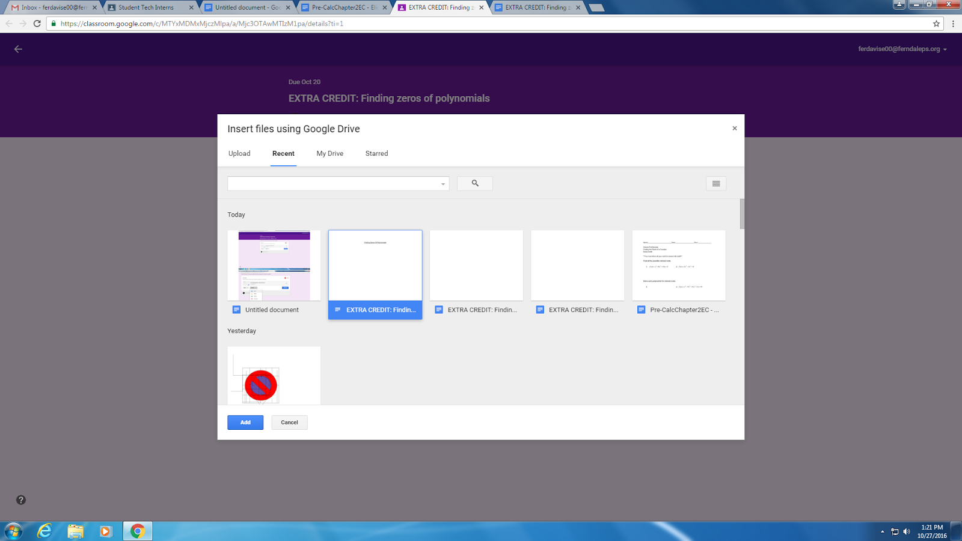

If you haven’t yet started on your work, click create to start a new file. Choose the type of project you would like to create and turn in. For now I will be choosing a word doc.

Before turning anything in, you either have to create or add a file with your work on it.

Once you have your file, start your assignment.

When you finish your assignment, go to the top right corner of your document and click **Turn In.**

Click **Turn in** when you are ready to turn in your assignment.

If you already have a document ready to turn in, Click **Add.** My document was in google drive, so I click google drive as my chose of attachment.

You would then choose the document you would like to attach. Then click **Add.**

After you select your file, turn in the assignment.